Name____________________________ Date: May 2020

Part 1: Multiple Choice. For each question, circle the best answer. 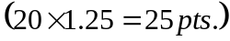
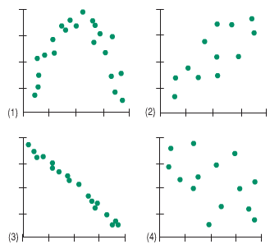
- Which scatterplot suggests that as number of college credits completed increases, earning potential also increases. _______
B
A
C
D

- A certain manufacturer claims that they produce 40% green candies. George plans to buy a large family size bag and Genni plans to you a small fun size bag. Which bag is more likely to have less than 20% green candies?

A. George B. Genni

C. Both the same chance D. Cannot be determined.

- Imagine you have a barrel that contains thousands of candies with several different colors. We know that the manufacturer produces 25% yellow candies. Five students each take a random sample of 20 candies and record the percentage of yellow candies in their sample. Which sequence below is the most plausible for the percent of yellow candies obtained in these 5 samples?

A. 25%, 25%, 25%, 25%, 25% B. 25%, 33%, 21%, 19%, 35%

C. 5%, 70%, 10%, 50%, 95% D. Any of the above.

- A farmer’s collection of pumpkins is weighed and the mean and median weight of the collection is calculated. Remarkably, the mean weight equals the median weight. The farmer’s daughter then adds her prize winning pumpkin (its huge!) to her father’s collection. Which is now a true statement?

A. The value of the mean is the same as the value of the median.

B. The value of the mean will be less than the value of the median.

C. The value of the mean will be more than the value of the median.

D. Cannot be determined.

- A gas station estimates that 32% of its gasoline customers also make an additional purchase inside the store. If the gas station supplies gas to 160 customers one morning, approximately how many customers also made a purchase inside the store?

A. 25 B. 32 C. 50 D. 100 E. 160

- In the standard normal model, state what approximate value of z cuts off the lowest 16%

A. -3 B. -2 C. -1 D. 1 E.2

- The volumes of soda in quart soda bottles can be described by a normal model with a mean of 27 oz and a standard deviation of 2 oz. Approximately what percentage of bottles can we expect to have more than 31 oz?

A. 5% B. 10% C. 16% D. 2.5% E. 68%

- Events which happen in succession in which the probabilities of the second event are affected by what happened during the first event are called:

A. Independent events B. Dependent events

C. Mutually Exclusive Events D. Mutually Inclusive events

- 75% of Americans brush their teeth before bedtime. 60% of Americans wear pjs to sleep. 50% of Americans both brush their teeth and put on pj’s before bed. The probability that a randomly selected American neither brushes their teeth nor wears pj’s to bed is:

A. 15% B. 25% C. 50% D.60% E. 75%

- A small box of chocolates contains 4 solid chocolate pieces, 5 caramels, and 3 mints. All candies are the same size and texture. If a person randomly selects one piece of candy and eats it and then selects a second piece, what is the probability of eating two mints?

A. 4.5% B. 6.25% C. 25% D. 30% E. 33%

- The alpha level was set for an experiment at α=0.05. A researcher just obtained statistically significant results. What type of p-value did she obtain?

A. A p-value larger than α=0.05

B. A p-value smaller than α=0.05

C. The magnitude of the p-value has no impact on statistical significance

- The linear relationship between variable x and y was found to be 0.2 while the correlation between z and y was found to be -0.8. Which of the following is a correct statement regarding the strength of the linear relationship?

A. The relationship between x and y is stronger

B. The relationship between z and y is stronger

C. The strength of the relationships is the same

D. It is not possible to determine based on the given information.

- A research article reports the results on the effectiveness of a new drug. The drug is used to fight breast cancer. The article gives a p-value of .68 in the analysis section. Which of the following statements represents a correct statement?
- The article is stating that the drug was found NOT to be effective.

- The article is stating that the drug was found to be effective.

- The p-value has nothing to do with whether or not the drug was found to be effective.

- A high school calculated a 95% confidence interval of (58.6, 89.3) for the percentage of seniors who they expect to attend the senior prom. Which statement is valid?

- 95% of the students will attend the prom for between 58.6 and 89.3 minutes.

- We are 95% confident that between 58 and 89 seniors will attend the prom.

- We are 95% confident that the confidence interval of 58.6 to 89.3 includes the true proportion of students who will attend the senior prom.

- There is a 95% probability that the true proportion is in the interval from 58.6 to 89.3.

- All but one of the following statements contain a mistake. Which one could be true?

A. The correlation between height and weight is 0.568 inches per pound.

B. The correlation between height and weight is 0.568.

C. The correlation between height and race is 0.47

D. The correlation between gender and age is –0.171.

- The normal density curve is symmetric about
  - Its mean
  - The horizontal axis
  - An inflection point
  - A point located one standard deviation from the mean

- An opinion poll asks a random sample of adults whether they favor banning ownership of handguns by private citizens. A commentator believes that more than half of all adults favor such a ban. The null and alternative hypotheses you would use to test this claim are
- $H_{0}: \hat{p}=0.5, H_{1}: \hat{p}>0.5$
- $H_{0}: p=0.5, H_{1}: p>0.5$
- $H_{0}: \hat{p}>0.5, H_{1}: \hat{p}=0.5$
- $H_{0}: p>0.5, H_{1}: p=0.5$

18. | 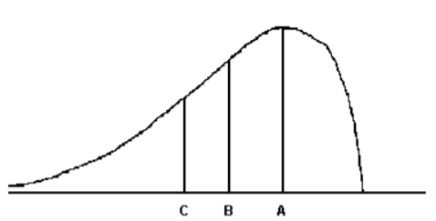  For the distribution drawn here, identify the mean, median, and mode.
 | A. | A = mode, B = median, C = mean | B. | A = median, B = mode, C = mean
 | C. | A = mode, B = mean, C = median | D. | A = mean, B = mode, C = median

19. | Parking at a large university has become a very big problem. University administrators are interested in determining the average parking time (e.g. the time it takes a student to find a parking spot) of its students. An administrator inconspicuously followed 300 students and carefully recorded their parking times. Identify the population of interest to the university administration.
 | A | the students that park at the university between 9 and 10 AM on Wednesdays | B | the parking times of the entire set of students that park at the university
 | C | the parking times of the 300 students from whom the data were collected | D | the entire set of faculty, staff, and students that park at the university

20. | The amount of corn chips dispensed into a 19-ounce bag by the dispensing machine has been identified as possessing a normal distribution with a mean of 19.5 ounces and a standard deviation of 0.2 ounce. Suppose 400 bags of chips were randomly selected from this dispensing machine. What is the probability that the sample mean weight of these 400 bags exceeded 19.7 ounces?
 | A | Approximately 0 | B | 0.1915
 | C | 0.3085 | D | 0.6915

Date: May 2020

Please show all work on this section. You will be graded on the completeness of your solution as well as the final answer. Each problem is worth 10 points holistically.

- The graphs below display the number of home runs hit by each team for Major League Baseball in both the American and National League during the 2012 season.

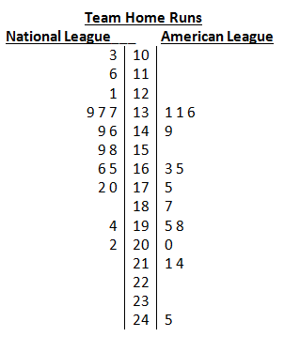
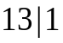 represents 131 homeruns

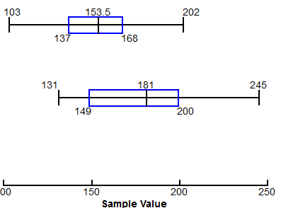

Compare the distributions in homeruns for teams in the two leagues. What conclusions can you make?

- In a small town with two schools, 1000 students were asked if they had a laptop. The results of the survey are shown below. One student is selected at random. Use this information to answer the following:
 | Students with a laptop | Students without a laptop | Total
School A | 365 | 156 | 521
School B | 408 | 71 | 479
Total | 773 | 227 | 1000

  - What is the probability that the student has a laptop?

  - What is the probability that the student attended school B, given that they have a laptop?

  - Are the events “has a laptop” and “School B” mutually exclusive (disjoint)? Explain.

  - Are the events “has a laptop” and “School B” independent? Explain.

- Sue, a starting player for a major college basketball team, made only 38% of her free throws last year. During the summer she worked on developing a softer shot in the hope of improving her free-throw accuracy. In the first eight games of this season Sue made 22 free throws in 40 attempts. Assume that these 40 attempts represent a random sample of free throws. Let p be the probability of making each free throw she shoots this season. Does this evidence suggest that Sue has made significant improvement in her free throw shooting? Let $α$ = 0.10. Be sure to include: the null and alternative hypothesis, the conditions, test statistic, and the conclusion in context.

  - An 80% confidence interval, for the true proportion of Sue’s made free throws, using the same point estimate, yields a lower bound of 0.449 and an upper bound of 0.650. How can you use this confidence interval to support your conclusion in problem above?

- The population distribution of college Student debt, as of May, 2019, is heavily skewed to the right with a mean debt of $30,000 and a standard deviation of $7510.
  - Explain why it is not possible to determine the probability that a randomly selected college student in your area, has a debt that’s less than $28,000.

  - Determine the probability that a random sample of 30 college students will have a mean debt of less than $28,000. Be sure to use the three step process to determine your solution.

- A packet of carrot seeds has a germination rate of 92%. In other words, the probability of any seed sprouting is 0.92. Let X be the number of seedlings in a row of 50 seeds?

- Show that this scenario follows a binomial setting.

- What is the probability that less than 45 of the seeds will produce seedlings?”

- What is the expected number and standard deviation of seedlings? Interpret both in context.

- Explain why this binomial setting does not follow an approximately Normal distribution.

- “Did you get your 8 hours of sleep last night? Is a common question. In a recent survey of 151 randomly selected post partum women, the folks at the National Sleep Foundation found that their mean sleep time was 7.7 hours, with a standard deviation of 1.4 hours. Assuming that eight hours is considered a good night’s sleep, does this evidence suggest that postpartum women do not get enough sleep?
  - Identify the parameter of interest and the hypotheses.

  - The resulting t-statistic is $-2.633$ and the P-value is 0.0047. What conclusion would you make at 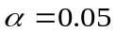level of significance, in context?

  - What type of error, Type I or Type II, could you make, based on your conclusion and what would it mean in context with the above scenario?

- A random sample of 50 recent college graduations results in a mean time to graduate of 4.58 years, with a standard deviation of 1.10 years. Source: Based on data from The Toolbox Revisited by Clifford Adelman, U.S. Department of Education

- Construct and interpret a 90% confidence interval to determine the mean time to graduate with a bachelor’s degree. Assume all conditions have been met.

- Does this evidence contradict the widely held belief that it takes 4 years to complete a bachelor’s degree? Explain.

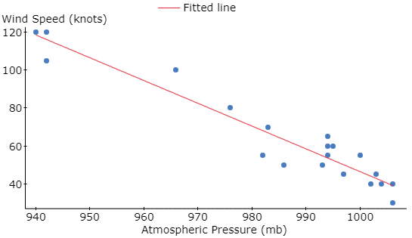
- The following data represent the maximum wind speed (in knots) and atmospheric pressure (in millibars) for a random sample of hurricanes that originated in the Atlantic Ocean. (5 points)
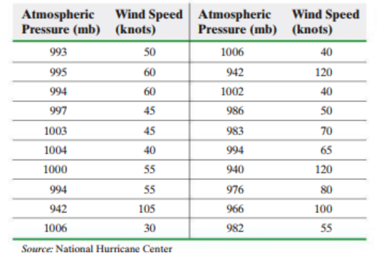
- Describe the scatterplot.

- The equation of the fitted regression line is $\hat{y}=1245.9405-1.199x$
where $\hat{y}$ = the predicted maximum wind speed (knots) and $x$ = Atmospheric Pressure (mb). Interpret the slope of this equation.

- What is the residual of the atmospheric pressure of 982 mb (from the table) and a max wind speed of 55 knots?

